Nepal College of Information Technology
Assessment Fall 2013
Program : BE ELX Time : 3 hrs
Semester : Fall (I) FM : 100
Subject : Engineering Mathematics I PM : 50

- Candidates are requested to give their answer as far as practicable in their own words.
- The figure in the margin indicates the full marks
- Attempt ALL question

 | - Define Transpose of a matrix. If A and B are two matrices of order m×p and p×n prove that (AB)^{T} = B^{T}A^{T}.  - Using the properties of determinant, show that  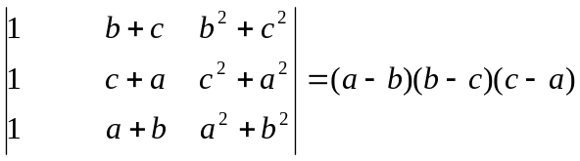 |  | 8  7
 | - Define rank of the matrix. Find rank of the matrix  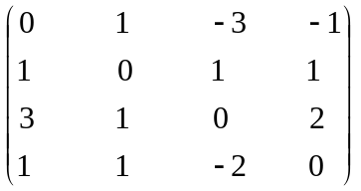  - Define consistence and inconsistence of a system of linear equations. Solve the given system of equations by using Gauss elimination method.  x + y + z = 8  x – 2y + z = 6  3x + 5y – 7z = 14 |  | 7  8
 | - Define eigen value and eigen vectors of the square matrix. Find eigen value and vectors of the square matrix 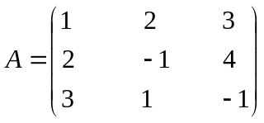  3.(b) Define the linear dependent and independent vectors, and verify that the vectors (1, 1, -1), (-1, 1, 1), and (1,-1, 1) are linearly independent or not. 8 |  | 7
4.(a)Define basis and linear transformation .Let V=R³ be a vector space. Show that (1,0,0),(0,1,0),(0,0,1) are basis of V. Let T:R²-R² defined by T (x,y)=(x,-2y) are linear or not. 7
4.b)Define periodic function with example. Find the fourier series representation of the function 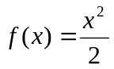for 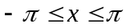 and then show that 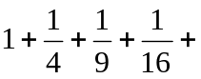.......... = 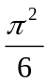 and 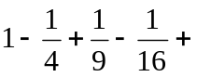........ = 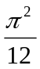. 8
5 . a) Write the Fourier coefficients of a function f(x). find the Fourier expansion of the function f(x) = x+|x| (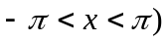. 7
5.b) Find the Fourier cosine as well as Fourier sine series of the function f(x) = sinx for 0<x<.∏ 8
- a)solve the linear programming problem by simplex method. Maximize the function 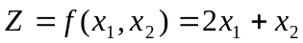subject to the conditions 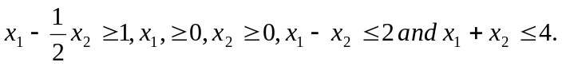 8
b) solve the linear programming problem graphically.
, maximize z=150x₁+300x₂ subject to the constant 7
7. | Solve the followings:  - 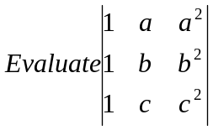  - Check even or odd or neither of the function f(x)=sinx+cosx  - Find the smallest period of sin(2∏nx/k)  - Prove that every square matrix can be expressed as the the sum of a symmetric and skew symmetric matrix.

